

<http://www.ongov.net/911/>

*J. Ryan McMahon, II**Julie K. Corn*

*County Executive Commissioner*

**Onondaga County Department Of Emergency COMMUNICations**

**2024 ANNUAL REPORT**



ANNUAL REPORT

ONONDAGA COUNTY DEPARTMENT OF EMERGENCY COMMUNICATIONS

Table of Contents

Executive/Administrative Division 4

2024 Accomplishments 5

2025 Goals & Objectives 5

Accreditation – CALEA 6

Emergency Communications Organizational Chart 8

911 Back-up Site 9

Community Involvement & Public Education 9

Policy Review & Oversight Committee 9

Police Users Group 10

911 Center Tours & Speaking Engagements 10

Technical Services Team – 911 Status Meeting 11

Senior Staff Meeting 11

Support for Volunteer Services 12

Meeting with Effected & Interested Parties 12

Affirmative Action /Equal Opportunity Policy & Program 12

Recruitment 13

Selection 13

Service Milestones 14

Retirements 14

Employee Turnover 14

Promotions 15

Employee Recognition 15– 17

10,000 Call Club 17

Operations/Call Taking 18

Text to 911 18

Telephone Call Stats 18

Wire-line/Wireless 911 Calls 19-21

Telecommunications for Non-English Speaking Population 22

Telecommunications for the Hearing & Speech Impaired (TDD) 23

Operations/Dispatch Services 23

Fire Department/EMS Dispatch DRs Assigned by Department & Division 24-27

Quality Assurance/Quality Improvement Program 28

Customer Satisfaction 28

Incident Review/FOIL Requests 29

Department Complaints/Organizational Integrity 29

Technical Services Division 30

Radio Division 30

Administrative Support Division 31

Professional Development 31

Training Division 32

Payroll 33

Business Office 33

2024 Budget, Preparation & Monitoring 33

**Executive / Administrative Division**

The Executive Department of the Department of Emergency Communications consists of the Commissioner, Deputy Commissioner of Operations and Deputy Commissioner of Administration/Technology. The Executive Department is responsible for planning, organizing, and directing the operations of the Department of Emergency Communications including the management of the Communications Center facilities, resources, equipment, and staff. The Executive Department also reviews system hardware and software and prepares specifications for the purchase of new systems as necessary and performs long-range resource planning as required. It develops and presents budget proposals for 9-1-1 Center operations and administers departmental expenditures and revenues.

**Mission Statement**

The mission of the Onondaga County Department of Emergency Communications is to serve as the critical and vital link between the citizens of Onondaga County and the public safety agencies that serve them**.**

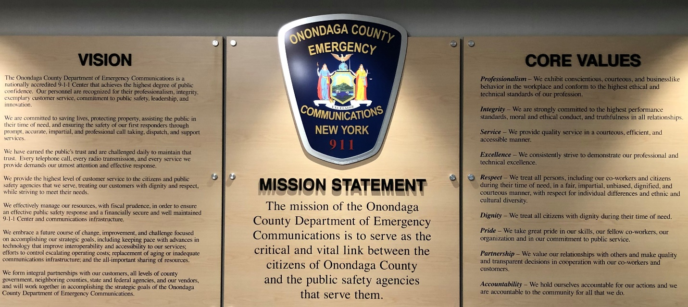

**2024 Accomplishments**

* Maintained Onondaga County’s reputation of successful operations: dispatched emergency calls for service to 94 police, fire, and emergency medical service agencies; operated the Onondaga County Interoperable Communications System (OCICS) that serves more than 160 local, county, state, federal and tribal public safety and public service agencies and approximately 9,500 radios in service of County residents and visitors; answered 91% of incoming emergency calls in ten seconds or less, meeting State Law and established professional standards.
* Record number of training and CTO hours completed
  + 28,060 total hours (topped 2023 by 317 hours)
  + 8,564 CTO hours (topped 2023 by 995 hours)
* Record number of new hires
  + 26 total (topped 2023 by 4)
* Record number of recruitment events
  + 39 total (topped 2023 by 30)
* CALEA Accreditation success continued
* Facebook, Wellness and Recruitment team success continued
* Nurse Navigation and Metal Health diversion program success continued
* CTO Incentive pay granted
* First 911 challenge coins; first time participating in the St Patrick’s Day Parade
* Filled System Administrator, Geographic Information System, and 2 Deputy Commissioner positions
* Radio system refresh project nearly complete

**2025 Goals & Objectives**

* Support Onondaga County’s priorities of: reducing the rate of poverty; investing in our infrastructure; and creating a climate that encourages economic development
* The E911 Center and all communications support systems are 100% reliable
* Calls for assistance are answered, processed and dispatched consistent with best practices and department values
* Operations achieve the highest degree of public confidence
* Operational and support services meet the operational needs of member public safety agencies
* All employees are knowledgeable and possess the requisite skills and abilities that allow them to complete their job tasks efficiently and effectively to the highest level of expectation
* Technology is strategically acquired, implemented, and utilized to improve customer service and assist personnel in accomplishing their work more effectively and efficiently
* Work with our Central New York Interoperable Communications Consortium (CNYICC) partners to explore cost sharing opportunities that would result in more cost effective, consistent, and efficient services to our communities
* Seek operating efficiencies in an effort to control costs necessary to remain within the 2025 Onondaga County Department of Emergency Communications budget as modified (BAM), especially in the area of personnel costs.
* Grow our workforce, maintain organizational effectiveness while under a labor shortage
* Build workplace culture based on trust, positivity, and accountability
* Foster an environment that prioritizes employee wellness and peer support

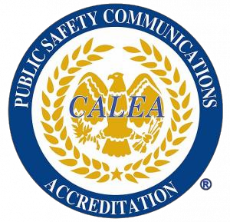**Public Safety Communications Accreditation**

The Onondaga County Department of Emergency Communications remains accredited through the Commission on Accreditation for Law Enforcement Agencies, Inc. (CALEA) and Training Program certified through the Association of Public-Safety Communications Officials (APCO). Accreditation shows the public, as well as the agencies we serve, that we are committed to pursuing a course of excellence in our daily operations.

**Commission for the Accreditation of Law Enforcement Agencies**

The Commission on Accreditation for Law Enforcement Agencies, Inc. (CALEA) has developed a comprehensive accreditation program for public safety communications centers. The CALEA Public Safety Communications Accreditation Program provides emergency communication centers with a process to systematically review and internally assess its operations and procedures. CALEA verifies standard compliance in seven key areas: Organizational Structure, Direction and Supervision, Human Resources, Recruitment, Selection and Promotion, Training, Operations and Critical Incidents, Special Operations and Homeland Security. Once accredited, an agency must demonstrate continued compliance with all applicable standards. Originally accredited in 2001, the Department of Emergency Communications has continued to successfully maintain accredited status. Each accreditation cycle covers a four-year period with annual compliance reviews required. The Department of Emergency Communications remains compliant with 100% of applicable standards having been awarded Accreditation with Excellence during our last full review in March 2021. The CALEA Accreditation with Excellence Award recognizes agencies for the effective use of accreditation as a model for the delivery of enhanced public safety services and management professionalism. The achievement of CALEA accreditation signifies that our agency is meeting the highest national standards for public safety communication centers. The Department successfully complete our latest assessment cycle culminating with an onsite assessment review in November 2024. The Department of Emergency Communications is scheduled to appear before the CALEA Commission in March 2025 to receive our 8th reaccreditation award.

**The Association of Public-Safety Communications Officials (APCO)**

**Training Program Certification**

The APCO Project 33 Agency Training Program Certification is a formal mechanism for public safety agencies to certify their training programs is meeting APCO American National Standards (ANS). The primary objective of the Agency Training Program Certification is to advance the training and professional development of public safety communications officials through the certification of an agency’s training program. Building and implementing a successful agency training program requires many resources and a good deal of dedication. Submitting for certification demonstrates the agency's commitment to training and to meeting national standards. Receiving certification for a training program is a major accomplishment for the agency, its staff, and the community it serves. The Department of Emergency Communications received our initial APCO Training Program Certification in 2019. The Department of Emergency Communications is currently seeking recertification and will submit for APCO review in 2025.

|  |
| --- |
| **ADMINISTRATION** |
| Commissioner |
| Deputy Commissioner - Operations |
| Deputy Commissioner -Administration |
| Executive Secretary to the Commissioner |
| PSSS – Administrative Support |
| PSSS – Radio Division |
| Administrative Assistant – Business Office |
| Administrative Aide – Payroll |
| Typist II – Operations Secretary |
| Incident Review |

|  |
| --- |
| **OPERATIONS** |
| PSSS – Public Safety Shift Supervisor |
| SODO – Supervisor of Dispatch Operations |
| PSD – Public Safety Dispatcher |
| PST – Public Safety Telecommunicator |
| Clerk II - NYSPIN |

[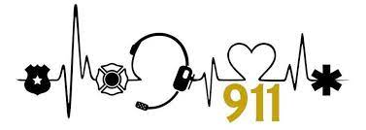](https://www.google.com/url?sa=i&url=https://www.facebook.com/Dispatchers/posts/found-these-great-decals-for-your-car-to-order-they-are-only-175-each-so-you-can/10155977301231160/&psig=AOvVaw3qtTJQ3CqYt2MLMr69c2hQ&ust=1620219545857000&source=images&cd=vfe&ved=0CAIQjRxqFwoTCPCxhrqKsPACFQAAAAAdAAAAABAu)

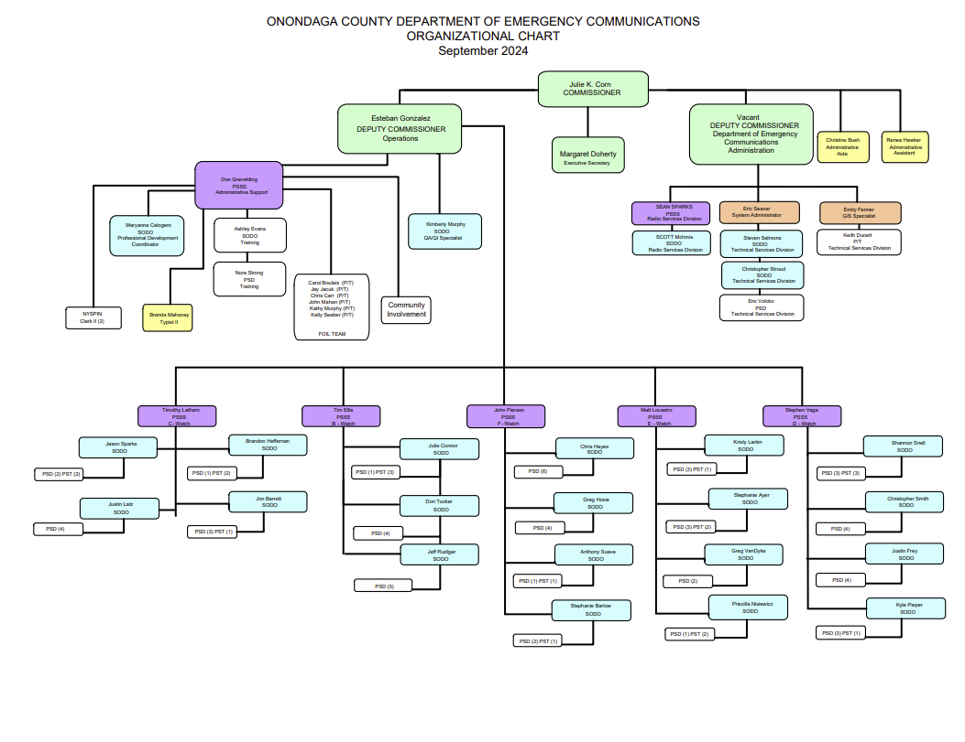

**9-1-1 Center Back-up Site**

The Department of Emergency Communications maintains a fully functional Backup Operations Center (BOC) located adjacent to the County Emergency Operations Center (EOC). The BOC is equipped with the same computer, telephone, and radio equipment and is capable of operating in stand-alone mode or in tandem with the primary 911 Center.

If the main 9-1-1 Center were to become inoperable for any reason, to ensure continuity of operations, the BOC is kept in standby mode and can assume operations until the operations are restored to normal. The BOC was activated once in 2024 to perform critical updates to our terminals and primary location servers. During this site activation, there were no notable issues encountered. The backup site is regularly maintained by the tech team so that transitions are smooth. This activation demonstrated that the backup site is ready to go whenever needed.

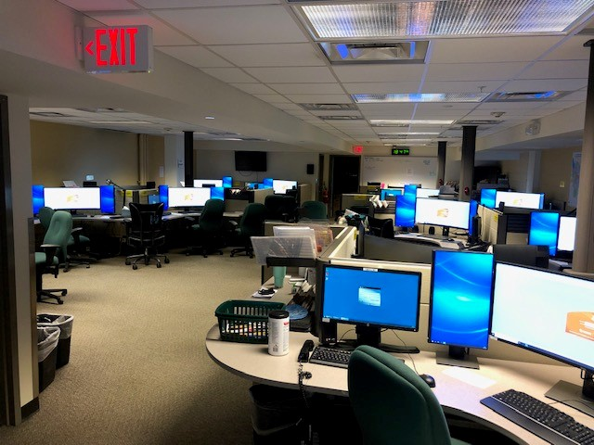

*Back-up Site (BOC)*

**Community Involvement & Public Education**

**Policy Review & Oversight Committee (PROC)**

A Policy Review and Oversight Committee was established to assure regular and ongoing participation of the heads of the affiliated emergency services throughout Onondaga County. The Policy Review and Oversight Committee address circumstances in which communications/dispatching functions affect the operation of emergency services. The Policy Review and Oversight Committee meets every other month (February/April/June/August/October/December) to discuss various operational policy and procedure issues directly related to communications and dispatching functions. The committee's primary role is to provide guidance through policy and operational practices review.

Membership of this Policy Review and Oversight Committee includes a chairperson designated by the County Executive, a representative from the County Executive’s Office, the Commissioner of the Department of Emergency Communications, the Onondaga County Sheriff, the Onondaga County Fire Bureau Director, the City of Syracuse Chief of Police, the Chief of the City of Syracuse Fire Department, the President of the Onondaga County Chapter of Chiefs Police Association, the Troop Commander from New York State Police Troop "D", the Onondaga County Commissioner of Emergency Management, the Chairperson of the Onondaga County Fire Chief’s Association, the Director of Onondaga County Emergency Medical Services Bureau, the Onondaga County District Attorney Representative, the Director of the Syracuse-Onondaga County Planning Agency, and the Commissioner of the Onondaga County Department of Information Technology.  Others may be invited on an ad hoc basis as appropriate in view of issues under discussion.

The PROC Committee met one time in April 2024.

**Police Users Group (PUG)**

Met six times in 2024. 911 Dispatchers and Line officer representatives attend this meeting to discuss operational issues between the dispatchers and road patrol units.

**Speaking Engagements, Tours, and Presentations**

Community Involvement activities include but are not limited to Tours, Public speaking engagements, Bring you Child to workday, recruitment as well as other activities and observations. We really intensified our recruitment efforts during 2024 in an attempt to return to approved staffing levels while taking advantage of the New York State HELP hiring initiative plan. Part of this entailed observations and tours.

During 2024, the Department of Emergency Communications conducted 23 tours at our Department and 46 outside speaking engagements/presentations throughout the community. We scheduled over 20 observations from various public safety agencies and potential candidates that would be taking future PSD/PST Civil Service Examinations.

We were able to offer “Bring your Child to work Day” along with allowing relatives of employees to sit with an employee and see what happens during their day at 911. The total was 46.

The approximate number of people reached/contacted through tours, observations, and presentations was 7215.

Our feedback received during these tours & outreach presentations continues to be very positive. During our presentations, a routine education outline is followed. The citizens participating indicated that they received a better understanding of the 911 Center once they had a visual of what takes place from the time the phone is answered and the reasons why we ask the questions we do.

During community education presentations, we sometimes receive information that may have a bearing on public safety communications within the community we serve. In order to alleviate potential problems, we will look into their issues and pass along information to a participating agency if involved.

We continue to work with our Amateur radio community, and they interact as a communication backup in case of radio system failure. We also continue to reach out to Neighborhood Watch Groups to receive invites to their area meetings to better educate the citizens of Onondaga County.

Tours that were conducted at the 911 Center:

Schools:

• OCM BOCES

• BOCES New Vision Criminal Justice Program

Member Agencies that attended a tour at the 911 Center:

• OSCO Recruit Class- March 2024 and September 2024 (27 Students)

• Tully Fire Department

* Minoa Fire Department
* Moyers Corners Fire Department
* Jamesville Fire Department

Presentations in our community included:

• Nottingham High School

* CNS – Cicero North Syracuse

• CW Baker High School.

• Huntington Family Center

• SPD

• Onondaga County Traffic Safety Advisory Board

• SU Career and Internship Fair

• CNY Works

• 911 – Emergency Services Career Fair

• SUNY Oswego

We continue to use our departmental Facebook page to share news about our center, staff accomplishments, advances in technology, public awareness and provide citizens a better understanding of the overall operation of the center.

**Senior Staff Meetings**

The senior staff of the 9-1-1 Center, which includes Executive Staff, Public Safety Shift Supervisors, and other senior managers meets monthly to exchange information such as the status of various projects, call statistics, training issues, absence statistics, quality reviews, fiscal status, and other pertinent issues.

7 Meetings in 2024.

**Support for Volunteer Emergency Services**

Onondaga County is served by 55 volunteer fire/rescue agencies and 14 non-profit emergency medical service (EMS) agencies. These agencies operate on often-limited resources, and in many cases do not have administrative support staff to keep the many different informational records and databases accurate and updated. The Department of Emergency Communications employees assist these agencies in providing information and expertise in planning their operations, equipment purchases, and interagency cooperative efforts. The 911 Center provides a representative to the County Fire Chief's Association, Central New York Fire Districts Association, and County Ambulance Directors to provide direct support to these important volunteer/non-profit resources. In addition, the Department performs many support services, such as oversight of maintenance and repair contracts for voice/data communications, tape reviews, and assistance with communications-related issues such as paging, alerting, and station printer networks.

**Meetings with Effected & Interested Parties**

The Executive Division works with citizen groups and emergency service provider agencies for coordination, support, and problem resolution as well as representing the Department of Emergency Communications in meetings with public boards and organizations, the news media, etc.

**Equal Employment Opportunity Policy and Program**

The Department of Emergency Communications Equal Employment Opportunity (EEO) program is set forth in Policy and Procedure Directive #1505. The purpose of this directive is to create an environment that ensures the same placement, training, promotion, and salary opportunities to all segments of the community.

**Authorized Strength**

PERSONNEL ALLOCATION

|  |  |
| --- | --- |
| TITLE | 2024 STAFFING |
| Commissioner | 1 |
| Executive Secretary | 1 |
| Deputy Commissioner | 2 |
| PSSS | 7 |
| SODO | 25 |
| PSD | 73 |
| PST | 11 |
| Clerk II | 2 |
| Administrative Assistant | 1 |
| Administrative Aide | 1 |
| Typist II | 1 |
| Vacant Positions | 15 |
| Part Time (103) Staff: PSD (12) PST (3) Clerk (1) Admin. Ast. (4) | 20 |
| TOTAL | 145 |

**Recruitment**

Continuing efforts are made to recruit the best qualified call takers and dispatchers. Recruitment is also conducted through our tours and public presentations to include school and career day programs and sit along observations, as well as partnering with Syracuse University S.I Newhouse School of Public Communications to provide a professional quality recruitment video. The department’s career brochure, “Career Opportunities at the Onondaga County Department of Emergency Communications” continues to be distributed. Our recruiting video is available on the front page of the department’s website. We also added recruitment “business” cards that can be handed out by employees detailing how and where to sign up for any upcoming 9-1-1 tests. As in previous years our agency continues to strengthen the relationship we have with our local colleges, recently partnering with Onondaga Community College for upcoming collaborative initiatives.

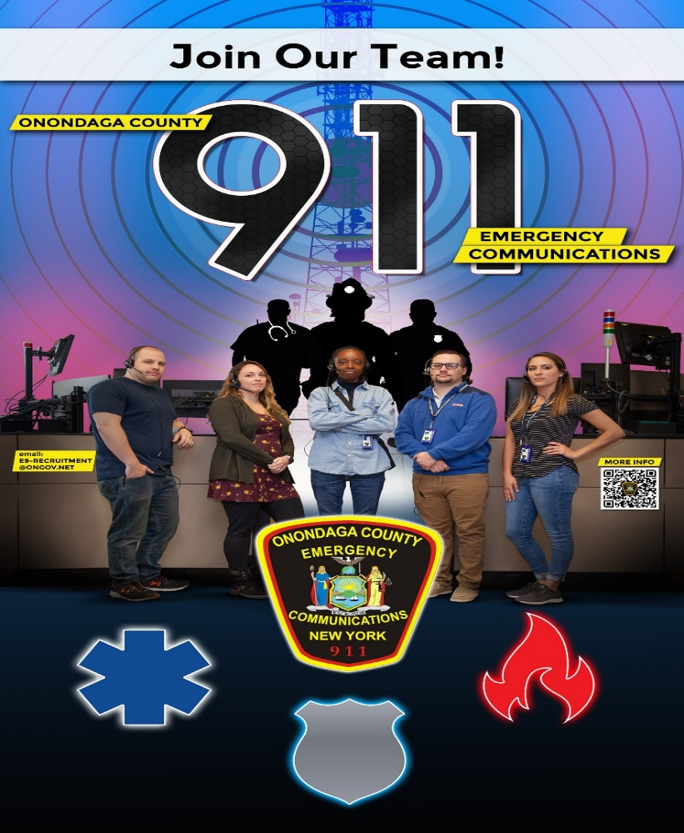

**Selection**

In 2024 the Department of Emergency Communications hired 26 new employees. At year-end,  
69.23% of those were retained, as compared to a past new hire retention rate of 59.26%. Two (2) new hires resigned during classroom training. Five (5) new hires failed during the classroom portion of training and One (1) failed during the On the Job Training (OJT) portion of the training.

**Service Milestones**

The following employees celebrated significant milestones of employment with Onondaga County Department of Emergency Communications in 2024:

|  |  |  |  |  |
| --- | --- | --- | --- | --- |
| **Over 35 Years of Service** |  | **Over 15 Years of Service** |  | **10 Years of Service** |
| Account Clerk Angela Greco |  | PSD Jeffrey Paquette |  | PSD Elizabeth Coll |
|  |  | PSD Loretta Bosco |  | PSD Kyle Pieper |
|  |  |  |  |  |
| **5 Years of Service** |  |  |  |  |
| PST Nacedah James |  |  |  |  |
| PSD Scott Cuff |  |  |  |  |
| PSD Kristal Wall |  |  |  |  |
| PSD Jessica Savo |  |  |  |  |

**Retired from Service in 2024**

|  |
| --- |
| Public Safety Dispatcher Dawn Burlingame – 30 Years of Service |
| Public Safey Shift Supervisor Patricia Fisher – 31 Years of Service |
| Public Safety Dispatcher Maria Gay – 30 Years of Service |
| Deputy Commissioner Benjamin Rinaldi II – 36 Years of Service |
| Public Safety Shift Supervisor April Smith – 32 Years of Service  Public Safety Dispatcher Michelle Thorpe – 35 Years of Service |

**Employee Turnover**

During 2024 (27) twenty-seven employees left the Department of Emergency Communications. The following chart summarizes employee turnover in 2024.

|  |  |  |
| --- | --- | --- |
| **Resignation** | **Retirement** | **Termination** |
| 7 PST’s | 4 PSD’s | 2 PST’s |
| 7 PSD’s | 1 DC | 1 PSD |
| 2 SODO’s | 1 PSSS |  |
| 1 DC |  |  |
| 1 System Admin |  |  |

**Promotions**

During 2024 the following employees were promoted/reinstated:

|  |  |
| --- | --- |
| Timothy Ellis | Promoted from SODO to PSSS |
| Stephanie Barlow | Promoted from PSD to SODO |
| Ashley Evans | Promoted from PSD to SODO |
| Jon Barrett | Promoted from PSD to SODO |
| Brandon Heffernan | Promoted from PSD to SODO |
| Justin Latz | Promoted from PSD to SODO |
| Greg VanDyke | Promoted from PSD to SODO |
| Taneesha Anthony | Promoted from PST to PSD |
| Allyson Florczykowski | Promoted from PST to PSD |
| Danielle Littleton | Promoted from PST to PSD |
| Karen Dailey | Promoted from PST to PSD |

**Employee Recognition**

### ***2024 Employee of the Year***

**Joshua Cantello**

The Department of Emergency Communications annually selects an Employee of the Year. This selection is based on the performance of an exceptional act, contribution of an outstanding idea, independently initiated self-improvement or accomplishment, outstanding community service, or sustained exemplary performance and conduct which demonstrates the ideals of honesty, integrity, and excellence.

***2024 Commissioner’s Award***

**Ashley Evans and Nora Strong**

The Commissioner’s Award is given by the Commissioner to help recognize individuals that have had a positive impact on the administrative or operational function within the organization.

***2024 Commissioner’s Supervisory Award***

**Brandon Heffernan**

The Supervisory Award is given by the Commissioner to the candidate that has shown initiative and leadership in the supervisory function and who has had a positive impact in his/her supervisory role within the organization.

***2024 Peer Awards***

A group made-up of the 9-1-1 Center’s rank and file employees choose the recipients of these awards. Those selected for 2023 are:

***2024 Police Dispatcher of the Year***

**Justin Frey**

***2024 Telecommunicator of the Year***

**Melissa Hilton**

***2024 Fire/EMS Dispatcher of the Year***

**Macey Arlukiewicz**

***Shane Daniels Positivity Award***

**Timothy Ellis**

***2024 Employees of the Month:***

The following employee was named Employee of the Month during 2024:

January – SODO Anthony Suave

***2024 Employees of the Quarter:***

PST Ashea Foster - Quarter 2

PST Nichole Chambers - Quarter 3

PST David Hoxie - Quarter 3

PSD Stephanie Barlow -Quarter 4

PSD Micheal Gallagher - Quarter 4

PSD Christie Hoefer - Quarter 4

***2024 Stork Pins***

Stork pins are awarded to call takers who guide a caller through labor, culminating in the birth of a baby prior to the arrival of first responders. Congratulations to the following employees who received Stork Pin Awards in 2024:

June – PST Melissa Hilton (2)

July – PST Valerie Sotherdon

August – PSD Dante Garofalo

September – PSD Heather Crowley

December – PST Corrina Strong

PST Valerie Sotherdon

***2024 Letters of Appreciation***

SODO Mary Anne Calogero

PSD Steve Arlukiewicz

PSD Jon Barrett

PSD Dawn Burlingame - 2

SODO Mary Anne Calogero

SODO Jake Carlson - 2

SODO Tim Ellis

PSD Maria Gay

SODO Greg Hoxie

PST Nededah James

PSD Sharmin LeBlanc

SODO Scott McInnis

PSD Kim Murphy

SODO Priscilla Nisiewicz -2

PSD Garrett Pazaras

SODO Steve Salmons

PSSS Sean Sparks

PSD Tyler Spellman

PSD Greg VanDyke - 2

PSD Nicole VanDyke

PSD Eric Volcko

PSD Brian Wall

PSD Abby Wells

PSD Tammy Wheeler

PSSS Don Grevelding

PSD Brandon Heffernan

PSD Todd Hildreth

PSD Dave Hoxie

PSD Anthony Sauve

PSD Jessica Savo

PSD Brittany Sgroi

PSD Jason Sparks

PSD Macey White

SODO Bobby Whitehead

PSD Greg Whitehead

[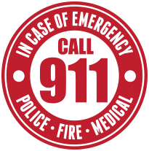](https://www.google.com/imgres?imgurl=http://www.cliparthut.com/clip-arts/214/emergency-911-www-pixshark-com-images-galleries-with-a-clipart-FG0J0v.png&imgrefurl=http://www.cliparthut.com/911-call-police-clipart.html&docid=FUx2Rm0_zd7C6M&tbnid=Qii5oJsCy92qVM:&vet=12ahUKEwi88ciM2OvhAhVhTd8KHYI-Di04yAEQMyg0MDR6BAgBEDU..i&w=205&h=207&bih=732&biw=1440&q=911%20telephone%20communication%20clipart&ved=2ahUKEwi88ciM2OvhAhVhTd8KHYI-Di04yAEQMyg0MDR6BAgBEDU&iact=mrc&uact=8)

***2024 - 10,000 CALL CLUB***

Recognition of staff who answered over 10,000 calls in 2024.

|  |  |  |  |
| --- | --- | --- | --- |
| Tia Britton | 16.358 | Melissa Barricella-Woodley | 11,294 |
| Frank Swierk | 11,622 | Alex Wormuth | 11,043 |
| Sheila Wolinski | 11,451 | Ahshea Foster | 10.919 |
| Necedah James | 11,328 | Leslie Murphy-Gibbs | 10.879 |

**OPERATIONS – CALLTAKING**

**“Text-to-911”**

During 2024, the Department of Emergency Communications Telecommunicators received and engaged in 1,969 “Text-to-911” sessions; a 38% increase over 2023. A “session” is defined as a user initiating a text message to “911” and receiving a response from the call-taker. Excluded from this number are test messages received. Of the 1,969 sessions there were 10,855 inbound messages and 11,737 outbound messages.

|  |  |  |  |  |  |  |
| --- | --- | --- | --- | --- | --- | --- |
|  |  | **OVERALL TOTALS** | |  |  |  |
| **Carrier** | **Number of Sessions** | **Number of Inboud messages** | | | **Number of Responses** | |
| Apple OTT-APOTT | 1 | 3 |  |  |  | 3 |
| ATTMO | 555 | 3189 |  |  |  | 3104 |
| DISHW DISH Wireless | 21 | 175 |  |  |  | 200 |
| TCS Telecommuncation Systems | 1384 | 7488 |  |  |  | 8430 |
| **Grand Totals** | **1961** | **10855** |  |  |  | **11737** |

**2024 Telephone Call Statistics**

The average speed with which 911 calls were answered in 2024 was 9.78 seconds. Callers take many paths to emergency assistance. The following data for 2024 shows how callers reached out for the first responder assistance.

|  |  |  |
| --- | --- | --- |
| Agency | # of calls |  |
| Clay PD | 23 | 0.004% |
| County Fire | 5,387 | 1.02% |
| NYS Troopers | 1,562 | 0.29% |
| Onondaga County Sheriff’s | 15,497 | 2.95% |
| Operator Assistance | 99 | 0.01% |
| Skaneateles PD | 146 | 0.02% |
| Solvay PD | 1,696 | 0.32% |
| Syracuse FD | 1,682 | 0.32% |
| Syracuse PD | 47,091 | 8.99% |
| Towns & Villages | 13,266 | 2.53% |
| Emergency 911 | 15,168 | 2.89% |
| Mobile 911 | 340,579 | 65.03% |
| Voice over Internet Protocol | 284 | 0.06% |

During 2024 the Department of Emergency Communications received a total of 523,660 incoming emergency calls. This number includes abandoned calls (i.e., a call placed in which the caller disconnects before the call can be answered by the E911 call taker) and non-emergency / information lines. A total of 86,697 calls were answered from persons who dialed a 10-digit line. These 10-digit lines are either legacy (pre-Enhanced 911) emergency numbers or listed by public safety agencies as “non-emergency” numbers. Emergencies are sometimes called in on 10-digit numbers but must be processed without the benefit of ANI/ALI (Automatic Number Information/Automatic Location Information) and therefore take longer to process. They are answered on an equal basis with incoming 9-1-1 calls. The Department of Emergency Communications encourages the use of 9-1-1 anytime there is a need for a police, fire, or emergency medical service response.

**Wire-line/Wireless Calls Answered**

The Department of Emergency Communications receives incoming 9-1-1 calls from two sources; wireline and wireless calls. Wire-line calls come from telephone devices that are connected to the traditional telephone system, including VoIP (Voice over Internet Protocol) systems (e.g., telephones from cable or fiber service providers). Wireless calls are received from devices that are not connected to a wired system (e.g., cellular phones). In 2024, 340,579 (65.03%) of the 9-1-1 calls were answered from wireless devices; 17,015 (2.89%) were from wire-line devices, with an additional 33,751 calls from VoIP lines. Wireless 9-1-1 calls take longer to process because location information is not as accurate, and customers who are mobile may not be familiar with their location. Since the 9-1-1 Center opened in 1992, the number of wireless 9-1-1 telephone calls has steadily increased.

**Answered 9-1-1 Calls by Source**

|  |  |  |  |  |
| --- | --- | --- | --- | --- |
| **Source** | **2022** | **2023** | **2024**  **Incoming** | **2024 Percent of Calls by Source** |
| Wire-line | 18,570 | 19,007 | 17,015 | 3.25% |
| Wireless | 295.859  36,658 | 335,581 | 340,579 | 65.04% |
| VoIP | 35,125 | 34,944 | 33,751 | 6.44% |
| 10-digit Emergency Line | 90,349 | 91,306 | 86,697 | 16.55% |
| Information Line | 16,806 | 13,870 | 11,311 | 2.16% |
| Abandoned Calls | 23,134 | 27,734 | 34,307 | 6.56% |
| TOTAL | 479,843 | 555,442 | 523,660 | 100% |

Abandoned Calls 2024

34,307 Total

94/ Day

3.91 / Hour

Emergency Communications Administrative staff made / received a total of 221,059 calls in 2024.

Incoming Admin Calls: 120,957

Outgoing Admin Calls: 110,102*

*The total number of outgoing calls from all positions is 151,527

**90/10 Analysis – Call Answer Time**

|  |  |  |  |  |  |  |  |
| --- | --- | --- | --- | --- | --- | --- | --- |
| **Month** | **Total Calls** | **Answer <10** | **% <10 Sec.** | **Answer <15** | **% <15 Sec.** | **Answer <20** | **% <20 Sec.** |
| January | 32,622 | 28,941 | 88.7% | 30,476 | 93.4% | 31,250 | 95.8% |
| February | 31,235 | 27,915 | 89.4% | 29,244 | 93.6% | 29,994 | 96.0% |
| March | 35,610 | 31,632 | 88.8% | 33,120 | 93.0% | 33,962 | 95.4% |
| April | 37,217 | 32,602 | 87.6% | 34,311 | 92.2% | 35,277 | 94.8% |
| May | 41,197 | 36,187 | 87.8% | 38,133 | 92.6% | 39,226 | 95.2% |
| June | 42,714 | 37,450 | 87.7% | 39,490 | 92.5% | 40,593 | 95.0% |
| July | 42,575 | 37,616 | 88.4% | 39,519 | 92.8% | 40,550 | 95.2% |
| August | 41,014 | 35,978 | 87.7 | 37,872 | 92.3% | 38,911 | 94.9% |
| September | 38,218 | 32,439 | 84.9% | 34,423 | 90.1% | 35,485 | 92.8% |
| October | 38,320 | 32,524 | 84.9% | 34.457 | 89.9% | 35,556 | 92.8% |
| November | 35,153 | 30,208 | 85.9% | 31,867 | 90.7% | 33,001 | 93.9% |
| December | 34,630 | 30,058 | 86.8% | 31,657 | 91.4% | 32,630 | 94.2% |
| **TOTALS** | 450,505 | 393,549 | **87.4%** | 414,569 | 92.0% | 426,435 | **94.7%** |
| *Target Goal* |  |  | *90.0%* |  |  |  | *95.0%* |

**Telecommunications for Non-English Speaking Population**

The Department of Emergency Communications has made a significant effort to ensure that all segments of the community have access to the County's emergency communications system. To address the needs of the non-English speaking community we have contracted with an over the telephone translation service which provides interpreters for over 140 languages. The following is a summary of the translation service usage during 2024:

|  |  |  |  |  |
| --- | --- | --- | --- | --- |
| Description | Calls | Minutes | % Calls | % Minutes |
| Spanish | 1031 | 7681 | 61.2% | 54.3% |
| Arabic | 292 | 2552 | 17.3% | 18.0% |
| Swahili | 105 | 1409 | 6.2% | 10.05 |
| Nepali | 22 | 199 | 1.3% | 1.4% |
| Kinya/Rwanda | 18 | 195 | 1.1% | 1.4% |
| Burmese | 8 | 88 | 0.5% | 0.6% |
| Dari (Afghanistan) | 22 | 174 | 1.3% | 1.2% |
| Mandarin | 31 | 244 | 1.8% | 1.7% |
| Somali | 28 | 184 | 1.7% | 1.3% |
| Karen | 4 | 33 | 0.2% | 0.2% |
| Vietnamese | 6 | 55 | 0.4% | 0.4% |
| Pashto (Afghanistan) | 11 | 134 | 0.7% | 0.9% |
| Bosnian | 4 | 130 | 0.2% | 0.9% |
| Farsi (Persian) | 7 | 89 | 0.4% | 0.6% |
| Urdu | 2 | 16 | 0.1% | 0.1% |
| French | 22 | 190 | 1.3% | 1.3% |
| Russian | 12 | 82 | 0.7% | 0.6% |
| Korean | 2 | 16 | 0.1% | 0.1% |
| Tigrigna (Eritrea) | 4 | 56 | 0.2% | 0.4% |
| Hindi | 6 | 44 | 0.4% | 0.3% |
| Haitian Creole | 13 | 151 | 0.8% | 1.1% |
| Italian | 1 | 8 | 0.1% | 0.1% |
| Turkish | 11 | 221 | 0.7% | 1.6% |
| Ukrainian | 11 | 113 | 0.7% | 0.8% |
| Cantonese | 1 | 9 | 0.1% | 0.1% |
| Rohingya | 2 | 4 | 0.1% | 0.0% |
| Brazilian Portuguese | 2 | 8 | 0.1% | 0.1% |
| Thai | 1 | 2 | 0.1% | 0.00% |
| Rohingya | 2 | 4 | 0.1% | 0.00% |
| Hausa | 1 | 4 | 0.1% | 0.00% |
|  | 1682 | 14095 |  |  |



**Telecommunications for the Hearing and Speech Impaired (TDD)**

Every call taking work station at the 9-1-1 Center and at the 9-1-1 Back-up Operations Site is equipped with the latest TDD technology that allows 9-1-1 Center staff to communicate with hearing and speech impaired individuals. The system is integrated with the department’s VESTA call taking solution. Personnel test the system daily and retrain every six months.

**OPERATIONS –DISPATCH SERVICES**

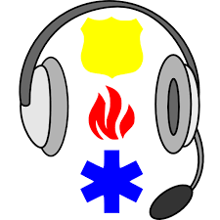**Dispatches/Incidents by Police Agency**

|  |  |
| --- | --- |
| **Department** | **#DR's** |
| **Baldwinsville Police** | 4,381 |
| **Camillus Police** | 15,257 |
| **Cicero Police** | 19,933 |
| **Dewitt Police** | 29,776 |
| **Geddes Police** | 15,526 |
| **Jordan Police** | 525 |
| **Liverpool Police** | 8,447 |
| **Manlius Police** | 31,139 |
| **Marcellus Police** | 340 |
| **New York State Police** | 43,676 |
| **North Syracuse Police** | 9,800 |
| **OCC Public Safety** | 698 |
| **Onondaga Co Park Rangers** | 4,206 |
| **Onondaga Co Sheriﬀ's** | 77,007 |
| **Skaneateles Police** | 1,820 |
| **Solvay Police** | 9,031 |
| **Syracuse Police** | 125,892 |
| **Syracuse Regional Airport** | 2,822 |
| **SU Public Safety** | 33,789 |
| **Upstate Police** | 2,012 |
| **New York State Park Police** | 221 |
| **Total** | 435,785 |

The total number of police dispatches in 2024, as reported, via the Computer Aided Dispatch (CAD) system was 435,785, a decrease of 17.66% from 2023 (125,892) Calls handled by the Syracuse Police Department accounted for 28.88% of the calls, while calls handled by County agencies (including the Onondaga County Sheriﬀ's, New York State Police, and others) accounted for 71.12% of all calls.

Dispatch data for City of Syracuse Fire/EMS for 2020 through 2024 is summarized below. The breakdown between fire calls and calls for rescue/emergency medical services are not available for the City of Syracuse. *Fire/EMS dispatches to the Syracuse Fire Department have dropped in recent years largely due to a change in the type of medical calls that the fire department will respond to.

**CITY OF SYRACUSE FIRE/EMS DISPATCH DATA**

|  |  |  |
| --- | --- | --- |
| YEAR | *TOTAL | % of CHANGE |
| 2020 | 15,927 | -29.5% |
| 2021 | 21,858 | +31.4% |
| 2022 | 24,402 | +11.64% |
| 2023 | 26,216 | +7.433% |
| 2024 | 25,704 | -1.9530% |

**County Fire/EMS Dispatch Data**

Dispatch data for Onondaga County Fire/EMS for 2020 through 2024 is summarized below. Final dispatch totals do not include 50,531 cases dispatched by AMR, in 2024.

**COUNTY FIRE/EMS DISPATCH DATA**

|  |  |  |
| --- | --- | --- |
| YEAR | TOTAL | % of CHANGE |
| 2020 | 60,028 | -6.2% |
| 2021 | 70,116 | +16.8% |
| 2022 | 74,744 | +6.6% |
| 2023 | 75,266 | +0.69% |
| 2024 | 73,141 | -2.8% |

The charts on the following page contain information regarding assigned DR numbers (Departmental Reference numbers) by fire agency* and EMS agencies for 2024, arranged by dispatch zone. Generally, a DR number corresponds to a dispatched incident or “run”. The departmental totals may not be complete for those departments whose jurisdictions contain areas outside Onondaga County.

Total Number of Dispatches in 2024

(Excluding AMR or Advised Incidents)

534,630

**Fire/EMS DR Information (The Fire Divisions changed last year)**

|  |  |
| --- | --- |
| **DIVISION 1** | |
| **Department** | **# Calls** |
| Northwest Fire District | 742 |
| Belgium Cold Springs | 938 |
| Lakeside | 596 |
| Plainville | 211 |
| Seneca River | 63 |
| Phoenix | 139 |
| Cody | 14 |
| **Total** | 2703 |
| **DIVISION 2** | |
| **Department** | **# Calls** |
| Hinsdale | 487 |
| Liverpool | 1096 |
| Mattydale | 1224 |
| Moyers Corners | 1296 |
| North Syracuse | 844 |
| Lyncourt | 520 |
| **Total** | 5467 |
| **DIVISION 3** | |
| **Department** | **# Calls** |
| Bridgeport | 876 |
| Brewerton | 318 |
| Cicero | 893 |
| Clay | 414 |
| Southbay | 407 |
| Caughdenoy | 43 |
| **Total** | 2951 |
| **DIVISION 5** | |
| **Department** | **# Calls** |
| Dewitt | 2393 |
| East Syracuse | 1171 |
| Fayetteville | 797 |
| Manlius | 800 |
| Minoa | 547 |
| Kirkville | 160 |
| 174th Air National Guard | 466 |
| **Total** | 5334 |

|  |  |
| --- | --- |
| **DIVISION 6** | |
| **Department** | **# Calls** |
| Amber | 132 |
| Navarino | 180 |
| Nedrow | 588 |
| Onondaga Nation | 507 |
| South Onondaga | 290 |
| Southwood | 406 |
| **Total** | 2050 |
| **DIVISION 7** | |
| **Department** | **# Calls** |
| Apulia | 162 |
| Delphi Falls | 89 |
| Fabius | 166 |
| Jamesville | 410 |
| Lafayette | 319 |
| Otisco | 178 |
| Pompey Hill | 391 |
| Tully | 187 |
| **Total** | 1902 |
| **DIVISION 8** | |
| **Department** | **# Calls** |
| Elbridge | 303 |
| Jordan | 289 |
| Marcellus | 258 |
| Mottville | 306 |
| Skaneateles | 406 |
| Spafford | 164 |
| Borodino | 165 |
| **Total** | 1891 |
| **DIVISION 9** | |
| **Department** | **# Calls** |
| Camillus | 374 |
| Fairmount | 857 |
| Howlett Hill | 491 |
| Onondaga Hill | 837 |
| Solvay | 1511 |
| Taunton | 422 |
| Warners/Memphis | 415 |
| **Total** | 4907 |
| **DIVISION 11** | |
| **Department** | **# Calls** |
| City of Syracuse **Total** | 25704 |

**2024 EMS Case Numbers by Agency**

Departmental Reference Numbers (DR’s)

|  |
| --- |
| **#DR’s for Ambulance Services** |
|  |
| AMR & / TLC53,954 |

|  |  |
| --- | --- |
| **#DR’s for EMS** | |
| Brewerton EMS | 1,080 |
| EAVES | 4.697 |
| Fayetteville EMS | 2,416 |
| GBAC | 4,975 |
| Jordan EMS | 1,538 |
| Lafayette EMS | 397 |
| Manlius EMS | 1.913 |
| Minoa EMS | 1,764 |
| MAVES | 2.376 |
| NOVA | 6,262 |
| NAVAC | 8,486 |
| SAVES | 1,189 |
| Syracuse University EMS | 15 |
| Syracuse Fire EMS | 1,956 |
| Tully EMS | 636 |
| WAVES | 3,529 |
| Physician Response | 2 |
| **Total DR’s for EMS** | **43,231** |

The Department of Emergency Communications dispatched, monitored activity on the command channel, TAC channels, and performed tasks associated with Signal 99 response plans for one hundred and thirty-three (133) Signal 99's during the calendar year 2024.

|  |  |  |
| --- | --- | --- |
| **Division** | **Signal 99 Alarms** | **Percentage** |
| 1 | 3 | 2.26 |
| 2 | 12 | 9.02 |
| 3 | 9 | 6.77 |
| 5 | 5 | 3.76 |
| 6 | 4 | 3.01 |
| 7 | 5 | 3.76 |
| 8 | 2 | 1.50 |
| 9 | 6 | 4.51 |
| 11 | 87 | 65.41 |



**ALARM CENTER**

The 911 Center monitors alarms for all County owned buildings and volunteer fire departments within Onondaga County. Listed below are the statistics for 2024. Of the direct alarms monitored by Silent Night, the direct alarms (3,747) were handled by Dispatchers and 14,115 were system self-tests. The 911 Center processed an average of 49 direct alarms per day in 2024.

|  |  |
| --- | --- |
| Total Signals Received | 52,348 |
| Auto-logged by System | 48,601 |
| Handled by dispatcher (Dispatchable) | 3,747 |
| System Self-Tests (Shift Verification) | 14.115 |
| Shift Verification Tests | 1,158 |

2024 Top Accounts. The following data does not include auto-logged signals or self-test verifications.

|  |  |
| --- | --- |
| Onondaga County Parks Rosamond Gifford Zoo | 8,970 |
| Onondaga County Carnegie Building | 3,101 |
| North Syracuse Fire Department Station 2 | 1.507 |

**Quality Assurance/Quality Improvement (QA/QI) Program**

The focus of the Department of Emergency Communications Quality Assurance & Quality Improvement (QA/QI) program is evaluating Telecommunicator and Dispatcher strengths as well as identifying areas for improvement. The QA/QI program is not meant to criticize errors, but to constructively review individual efforts, to recognize if complacency is creeping into our work and to find areas in which we can improve. Our comprehensive QA/QI programs include random and live review of calls received/processed and dispatches of police, fire and EMS resources. Quarterly audits of employee use of computer databases are included in this program. Operation Supervisors, with the management of our Quality Assurance Specialist, regularly monitor, review, and evaluate performance. All quality assurance checks are reviewed with individual employees. The Quality Assurance Specialist and Shift Supervisors ensure all appropriate review, training and remediation is provided when a need is identified. The Department of Emergency Communications maintained a 99% overall protocol compliance for 2024. Our goal remains to deliver the best possible service to the citizens of Onondaga County and those agencies we serve.

**Customer Satisfaction**

The Department of Emergency Communications is committed to providing the best possible service to our community. To help assess our performance, the department sends surveys for feedback. Citizens are asked questions on a variety of topics such as “The attitude and helpfulness of the call taker?”, “The knowledge of the call taker?” The courtesy of the call taker and “satisfaction with the call taker?” During 2024, 12,648 surveys were requested. Of those, 3,779 responses were received. Out of these responses, 17,509 questions were answered with an 88.82% positive satisfaction score.

Citizen Score shown below:

**Incident Reviews/FOIL Requests**

Every telephone call received by the Onondaga County Department of Emergency Communications and all radio transmissions are recorded on a logging recorder system. For 2019 Departmental Policy & Procedure Directive #2014, "Digital Voice Recording Reviews and Holds”, specifies that copies of telephone calls and radio transmissions be retained for 1 year unless a specific request is received to place a hold on specific audio copies of calls.

Computer Aided Dispatch (CAD) records are maintained for three years in accordance with the New York State Archives Records Retention and Disposition Schedule (CO-2) requirements. Incident reviews and FOIL requests are processed in accordance with Section 306b of the New York State County Law and Section 39 of the New York State Public Officer’s Law.

Eight (8) part-time employees processed all requests for audio reviews made by public safety agencies, government agencies (e.g., District Attorney’s Office) and Freedom of Information Law (FOIL) inquiries for 2024.

During 2024 the total number of audio and data review requests completed by the review office was 8546, a decrease of 7.25% over 2023. The total number of FOIL (Freedom of Information Law) specific requests was 104, an increase of 50.73% from 2023. The total number of requests from the District Attorney’s Office was 6555, a decrease of 8.28% from 2023.

**Department Complaints/Organizational Integrity**

It is the policy of the Department of Emergency Communications to courteously receive, document and investigate all complaints against the agency or its employees. In accordance with Policy & Procedure #0018, “Organizational Integrity,” all complaints (both external and internal) are a part of this analysis for the purpose of the maintenance of professional conduct by ensuring an appropriate response to allegations of employee misfeasance, malfeasance, nonfeasance and to complaints about the department’s response to our customers.

The information compiled for this report is extracted from several different databases and computer systems housed at the Department of Emergency Communications. These systems include VESTA Analytics (call-taking statistics), Intergraph CAD, 2023 Frontline Pro Standards, and the departmental Training database.

**General Overview:**

Of the 523,660 incoming emergency and non-emergency telephone calls, 688,281 dispatches (police, fire, and EMS), 391,345 operational non-emergency calls received/made, and 7,336,339 radio transactions performed by the Department of Emergency Communications Operations in 2024. As a department, we received a total of 72 complaints (internal and external sources) that were filed resulting in a formal complaint investigation. All of the complaints received pertained to department operations and/or personnel.

The number of complaints (including sustained, unfounded, exonerated, not sustained, withdrawn, and other findings), compared to calls answered/radio dispatches (communications transactions) is shown below:

|  |  |  |  |  |  |  |  |
| --- | --- | --- | --- | --- | --- | --- | --- |
| **Complaints** | **Sustained** | **Unfounded** | **Exonerated** | **Not Sustained** | **WD** | **Other** | **Total** |
| **Citizen** | **6** | **10** | **1** | **0** | **0** | **0** | **17** |
| **Member Agency** | **16** | **4** | **4** | **1** | **0** | **0** | **18** |
| **Other Agency** | **0** | **0** | **0** | **0** | **0** | **0** | **0** |
| **Other** | **0** | **0** | **0** | **0** | **0** | **0** | **0** |
| **Total** | **22** | **14** | **1** | **1** | **0** | **0** | **38** |

**Technical Services/Radio Divisions**

**Technical Services Division**

The Technical Services Division manages all key technology related systems for the department. These critical systems include: Computer Aided Dispatch (CAD), Mobile Data Communications Network (MDCN), Geographic Information systems (GIS), administrative PC’s, software and peripherals, 9-1-1 call taking systems which include text to 911, Fire/EMS/Police response plans, and 9-1-1 addressing. The Technical Services Division was instrumental in the implementation of the ASAP to PSAP system which allows alarm monitoring companies to upload alarm calls directly to the CAD system for dispatch, saving time and eliminating redundancy. In addition to these tasks, the COVID-19 pandemic required the entry of statistics provided by the Onondaga County Health Department that were used to keep first responders safe while working during the pandemic. All this must be maintained on a 24/7 basis and members of the Technical Services Division work an on-call rotation, in cooperation with the Radio Division, to ensure any potential issues are averted.

**Radio Division**

The Radio Division manages the Onondaga County Interoperable Communications System (OCICS) UHF P25 trunked land mobile radio (TLMR) system which provides county-wide two-way radio coverage for 160 local, county, state, federal, and tribal public safety and public service agencies operating within Onondaga County. Those agencies alone operate more than 11,500 subscriber radios (i.e., portable, mobile and control stations) on the OCICS system. To accomplish this, the Radio Division maintains the TLMR Master Site Controller, dispatch consoles, and 16 remote communications tower sites located throughout the county which are linked via the Common User Microwave Relay System (CUMRS). The Radio Division provides end user support services, statistical analysis reporting, and subscriber equipment accountability. The Department works as a member of the Central New York Interoperable Communications Consortium (CNYICC) to interconnect neighboring county radio systems into the Onondaga Master Site including Broome, Cayuga, Jefferson, Madison, Oneida, and Oswego counties. The Radio Division provides technical support to the shared master site counties to ensure the goal of region-wide interoperable communications is met. Again, this all needs to be maintained on a 24/7 basis requiring members of the Radio Division work an on-call rotation, in cooperation with the Technical Services Division, to ensure any potential issues are averted.

**Administrative Support Division**

The Supervisor of Administrative Support oversees administrative services such as the agency’s administrative reporting, organizational integrity function, recruitment, and selection, and serves as the department liaison with police, fire, and EMS providers while overseeing the training division, Professional Development, and performs any other duties as assigned by the Deputy Commissioner’s or Commissioner.

**Professional Development**

The Professional Standards/Development Coordinator serves as the department’s Accreditation Manager. The position oversees policy and procedure review, grant management and ensures the agency remains compliant with all applicable CALEA and APCO Training standards.

**Training Division**

|  |  |  |  |  |  |  |
| --- | --- | --- | --- | --- | --- | --- |
| TOPIC | #EMPLOYEES | TOTAL HRS |  | TOPIC | #EMPLOYEES | TOTAL HRS |
| Roll Call - 8hr Employees | 66 | 208.00 |  | FIRE/EMS Dispatch | 8 | 3083.50 |
| Roll Call - 12hr Employees | 42 | 108.00 |  | Portal | 54 | 54.00 |
| New Hire - PST | 26 | 15,286.75 |  | CTO Training | 16 | 210.00 |
| Dispatch Cross Train – Class | 4 | 288.00 |  | Critical Asset Risk Mgt | 1 | 16.00 |
| Dispatch Cross Train-OJT | 4 | 1,543.00 |  |  |  |  |
| EMD Refresher | 5 | 120.00 |  | Information Security | 143 | 35.75 |
| Remedial Training | 1 | 144.00 |  | Supervisor Promotion Class | 6 | 480.00 |
| ARTSS x 12 Deliveries | 12 | 922.00 |  | Supervisor Rater | 28 | 28.00 |
| FEMA IPAWS | 8 | 16.00 |  | NYSPIN | 3 | 240.00 |
| NCMEC | 39 | 69.50 |  | Peer Support Training | 7 | 28.00 |
| DCJS/CJIS | 43 | 64.75 |  | Defensive Driving | 10 | 60.00 |
| CPR-AED Original | 46 | 46.00 |  | Sexual Harassment | 147 | 147.00 |
| PSSS Training | 1 | 80.00 |  | Variance Training | 148 | 37.00 |
| MRD Dispatch Training | 5 | 2,468.65 |  | Rapid SOS | 1 | 8.50 |
| SPD Dispatch Training | 4 | 1,491.75 |  | Radio Template Refresh | 50 | 50.00 |
| Responder Strong | 1 | 8.00 |  |  |  |  |
| DCJS IDC | 3 | 240.00 |  | APCO 911 Wellness | 1 | 6.00 |
| Return to work | 3 | 54.00 |  | Tactical Dispatcher | 1 | 32.00 |
| CAD System Administrator | 1 | 63.00 |  | Diversity Equity | 133 | 133.00 |
| Mobile System Admin. | 1 | 36.00 |  | Courtroom Testifying | 2 | 16.00 |
| Town of DeWitt Fire Resp. | 5 | 5.00 |  | TOTAL TRAINING HOURS | | 27,927.15 |

**2024 Training Hours**

2020 Training Hours = 7,473.26

2021 Training Hours = 9,972.50

2022 Training Hours = 19,526.50

2023 Training Hours = 27,742.50

2024 Training Hours = 27,927.15

**Payroll**

The Payroll Clerk is responsible for administrative personnel functions (e.g., processing status changes, employee benefit assistance), employee timekeeping, civil service processing and compliance, and biweekly payroll preparation. The Payroll Clerk also serves as a liaison to the Department of Personnel.

**Business Office**

**Budget Preparation & Monitoring**

The 9-1-1 Center’s Business Office works closely with the Executive Division of the Department of Emergency Communications, and the Onondaga County Financial Operations Department to prepare the Department’s annual budget request for submission to the Onondaga County Department of Management & Budget. Throughout the year the Business Office monitors the budget, alerting the Executive Division and Financial Operations when potential problems are first identified.

**2024 Budget**

**This is a summary of the 2024 Department of Emergency Communications budget:**

|  |  |  |
| --- | --- | --- |
|  | **Sum of Budget** | **Sum of Expense** |
| Personnel Expense | 10,370,602 | 12,216,589 |
| Employee Benefits / Fringe | 4,115,956 | 4,447,364 |
| Expenses | 3,887,439 | 3,253,179 |
| Debt Service Expense | 1,723,790 | 1,172,790 |
| **Total Expense** | 20,097,787 | 21,089,922 |
| Revenues | 3,723,900 | 3,724,608 |
| **Local Dollars** | 16,373,887 | 17,365,314 |